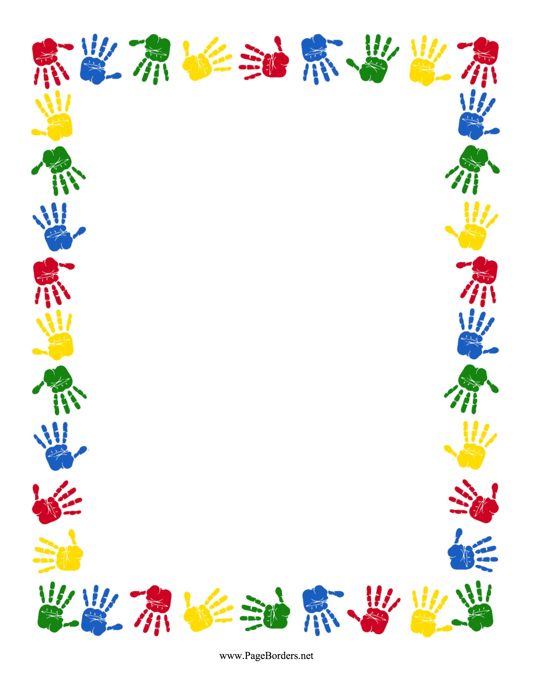

**Bywood Elementary School**

**First Grade Supply List**

**2023-2024 School Year**

Welcome to Bywood!!!

We are so excited to work with your children this year.

Please see the following supply list and try your best to purchase everything to support your child!

1 Pencil Case

4 **plastic** folders (red, yellow, green, blue preferred)

3-5 Packs of Pencils

4-6 Boxes of Crayola Crayons

3-6 Elmer’s Glue Sticks

1-2 Packs of **Black** Dry Erase Expo markers

1 Pack of Paper Towels

2 Containers of Clorox disinfectant wipes

1 Pack of Baby Wipes

1 Bottle Hand Sanitizer

3-5 Boxes of Tissues

1 Box of Gallon Size Ziplock Bags

Thank you for **ALL** your support.

We are looking forward to a great school year!